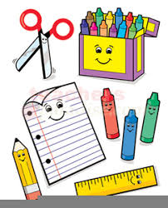 **Kindergarten Supply List** 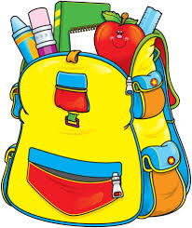

**2023-2024**

Welcome to Kindergarten! We are asking for your cooperation in getting your child ready to enter kindergarten. *Please bring all supplies to the K-Orientation. Please label your lunchbox and backpack with your child’s first name and last initial.

Backpack – No Wheels

Lunchbox (your child will need a nutritious snack each day)

Sports top water bottle (no spill)

Headphones for computer (no earbuds)

1 Red, 1 Blue, 2 Green bottom pocket folder (plastic with 3 prongs)

4 small Elmer’s Glue sticks

4 boxes of **Crayola** crayons (box of 8 / 16 classic colors)  **NO JUMBO**

1 pair of **Fiskar** scissors

12 yellow No. 2 **Ticonderoga** pencils **PLEASE SHARPEN**

1 Pink Eraser (not a pencil topper)

6 **Expo Low Odor** dry erase markers (**black**) (**thin**)

1 Yellow highlighter

1 pack of 3X3 post-it notes

Lysol wipes

**Wish List**:

1 Gallon-sized zip lock bags/1 Sandwich-sized zip lock bags

Tissues (Please!)

2 oz container of Play-Doh (labeled) (any color)

1 package of baby wipes

Thank you!

The Kindergarten Teachers